**Bước 1: Download những chương trình cần thiết:**

Dowload những file cần thiết lưu trên desktop cho dễ cài đặt.

<http://download.oracle.com/otn-pub/java/jdk/6u25-b06/jdk-6u25-windows-i586.exe>

<http://nchc.dl.sourceforge.net/project/xampp/XAMPP%20Windows/1.7.1/xampp-win32-1.7.1-installer.exe>

<http://download-ln.jetbrains.com/idea/ideaIU-11.1.1.exe>

<http://apache.oss.eznetsols.org/maven/binaries/apache-maven-2.2.1-bin.zip>

<http://msysgit.googlecode.com/files/Git-1.7.9-preview20120201.exe>

<http://tortoisegit.googlecode.com/files/TortoiseGit-1.7.7.0-32bit.msi>

**Bước 2: Setup GIT (Source Version Control):**

* Chạy file TortoiseGit-1.7.7.0-32bit.msi

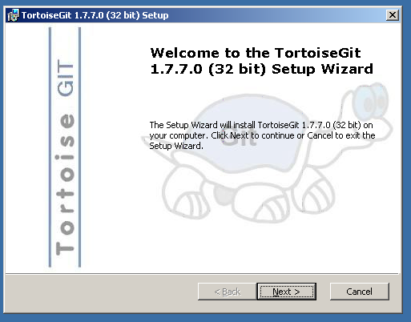

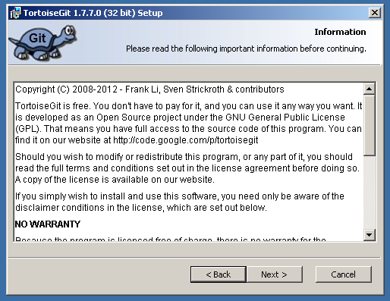

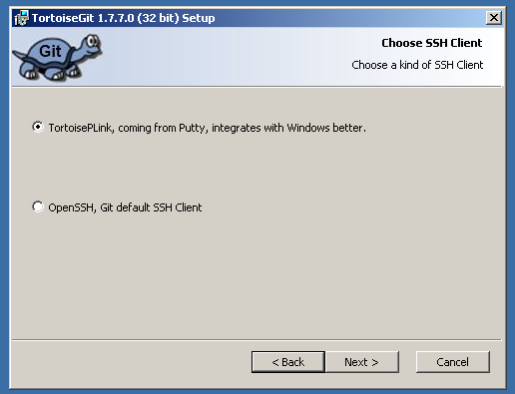

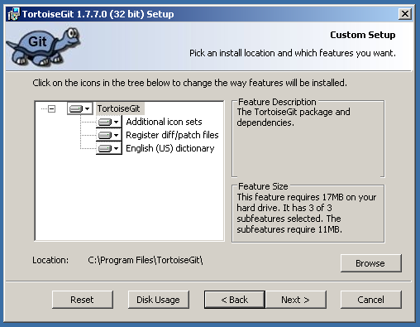

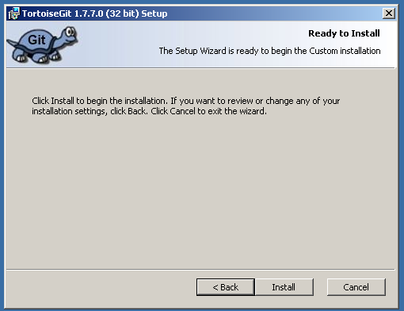

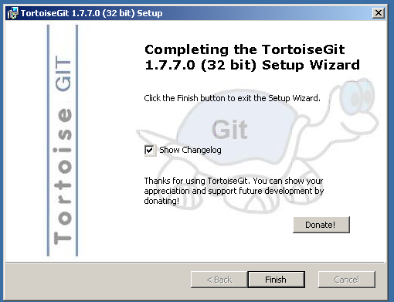

* Chạy file Git-1.7.9-preview20120201.exe

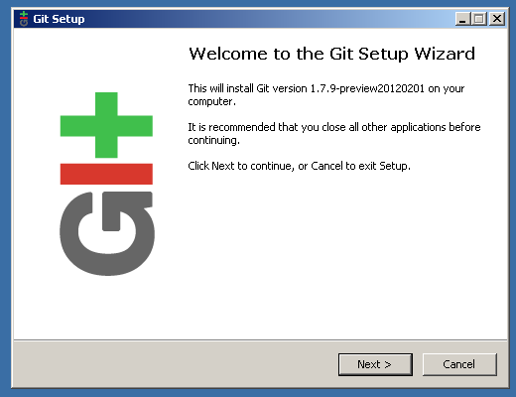

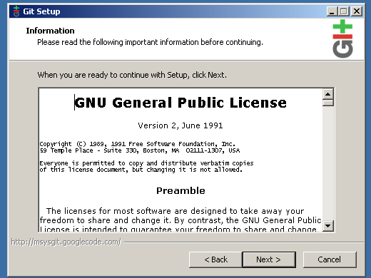

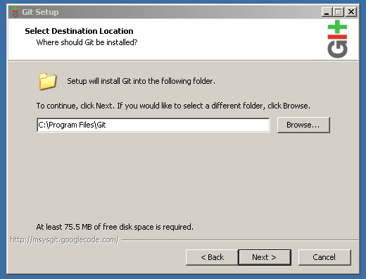

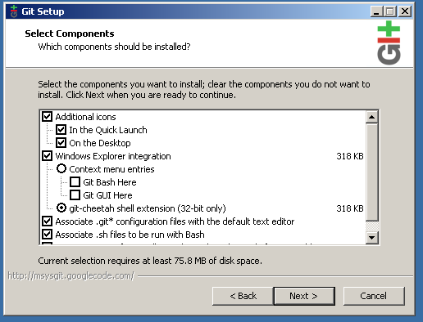

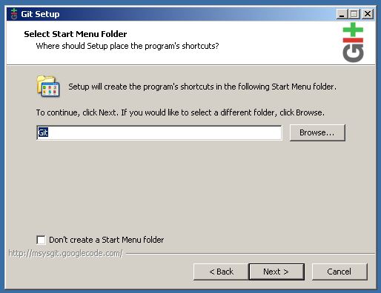

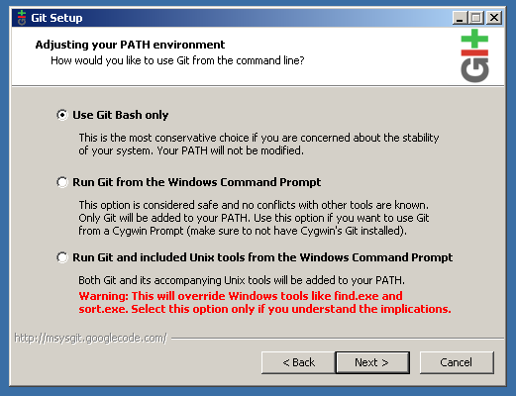

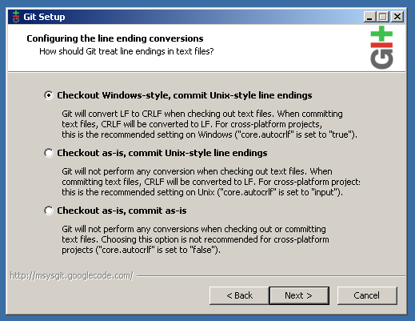

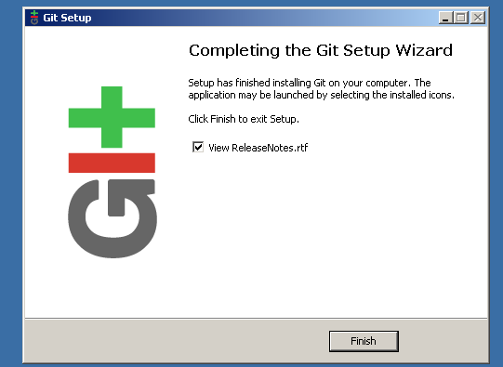

**Bước 3: Download code:**

Xem video hướng dẫn

<http://dl.dropbox.com/u/838791/download%20code.swf>

**Bước 4: Build Project:**

Xem video hướng dẫn

<http://dl.dropbox.com/u/838791/how%20to%20build%20code.swf>

**Bước 5: Setup server:**

Xem video hướng dẫn

<http://dl.dropbox.com/u/838791/setup%20server.swf>

**Bước 6: Setup IDEA (dùng để lập trình):**

Xem video hướng dẫn

Name: www.serials.ws Serial: 72332-53V9G-YYJW1-37EHG-KNPDY-EFNL4

<http://dl.dropbox.com/u/838791/setup%20idea.swf>

**Bước 7: Chạy website:**

Xem video hướng dẫn

<http://dl.dropbox.com/u/838791/run%20app.swf>